Commuter Challenge Email Templates Week 1 (May 1st -7th)
Missoula In Motion has prepared some sample email messages that might be useful to you as you spread the word about the Commuter Challenge in your workplace. Feel free to edit the materials to suit your purposes, style, weather etc. (please note the red bolds and edit as appropriate):

Send out date: Friday, April 29th
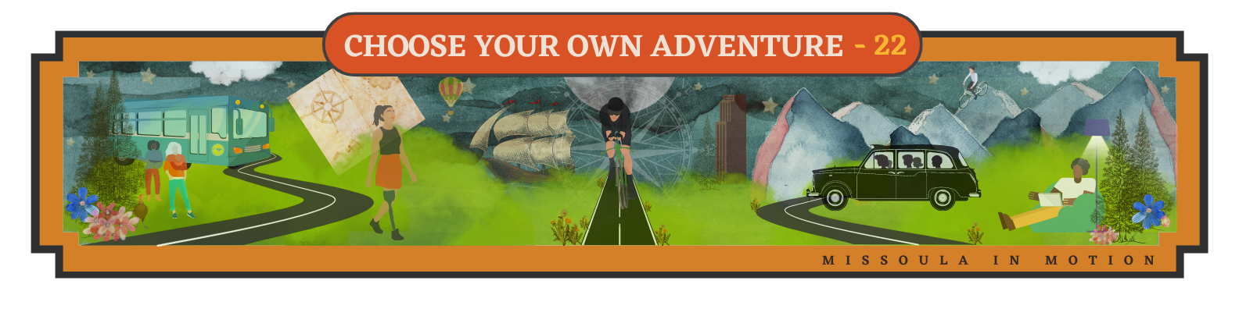
Missoula In Motion's annual Commuter Challenge is just around the corner. From May 1st - 14th workplace name is going for the WIN and we’re gonna have fun doing it! (If won previously: “We won last year and must defend our title”.)

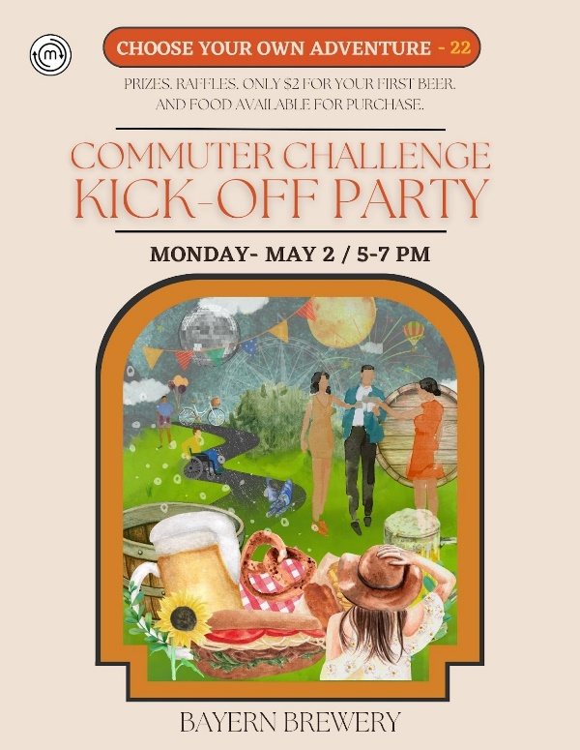
The Commuter Challenge is a head-to-head competition where we compete against other similarly sized workplaces to see who can commute sustainably the most from May 1-14. The challenge is an opportunity to discover all our money saving travel options, create new healthy habits and win some sweet prizes!

Everyone is invited to the kickoff party at Bayern Brewing on Monday night from 5-7. $2 beverages for all challenge participants!

The big prize is a pizza party! If we are the ONLY team in our size category to have everyone commit to traveling by any mode other than driving alone ONE time, ONE commute during May 1-14 then we WIN that FREE PIZZA PARTY! One time, one trip. That’s it!

So rather than automatically hopping in your car to get to the office, think about a new way! Hop on the free Mountain Line bus or put on a podcast and enjoy the sun with a walk! The theme of this year’s challenge is “Choose Your Own Adventure”. You’re the star of the story so the path is yours to choose. You never know what adventures you might have along the way!

And yes, working from home is absolutely a sustainable mode that is eligible during the Commuter Challenge! Let me know if you have any questions.

Start logging those sustainable commutes with Way to Go!

Signed, XXXXXX
Your Commuter Challenge Captain

Send out date: Wednesday, May 4th
Team Workplace Name,

Last time I mentioned the big prize, but there are other ways to win too! Have you heard about the daily raffle drawings? Log today’s sustainable commute with Way to Go before 12pm tomorrow to be entered to win a gift card to The Old Post! Check the raffle schedule for this week:
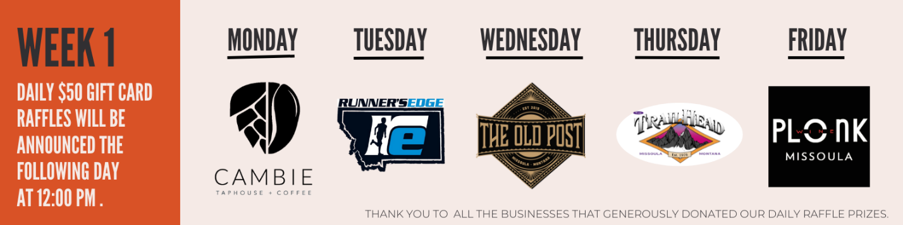

- New this year: MODE EXPLORER

There is a big raffle prize for the adventurous folks who try at least 3 sustainable modes of transportation during the challenge! Everyone will receive an Achievement badge in WayToGo for each commute mode used during the challenge. All participants with 3 or more Achievement badges will automatically be entered into a raffle that we’ll present at our Awards Party on Tuesday June 7th at Western Cider from 5-7pm.

New to Way to Go! or need a refresher on how to log a trip? Check out this guide to help! And remember team, we're looking for at least ONE trip, ONE time from everybody on Team Workplace Name. Help us bring home that win!

Signed, XXXXXX
Your Commuter Captain
Send out date: Friday, May 6th

Hooray, we’ve made it through week one of the Commuter Challenge! Great work everyone, especially Bob, Jim, & Mary (please change names to reflect people in your organization) who are well on their way to perfect participation and winning that free ice cream!

If you haven’t had a chance to spend some time exploring all the useful features on Way to Go! Missoula, it’s worth your time. Way to Go! highlights include:

- Guaranteed Ride Home. If you use a sustainable mode, but need to pick up your child from school during the day or get home in the snow we’ll reimburse the cost of your taxi, uber, lyft, etc.
- Carpool matching platform to search and connect with others to share rides with
- Bike routes based on your preference - either a more comfortable or more direct route
- Automatically earn monthly prizes when you log trips – even when the Challenge is over!

...and so much more!

Don’t forget, if we are the only team in our size category to get everyone to log a sustainable commute, we win a team pizza party!! And every day you log a sustainable trip you’re entered into a raffle for a $50 gift card. Let’s win this thing!

Happy weekend!

Signed, XXXXXX
Your Commuter Captain

