Commuter Challenge Email Templates Week 2 (September 20-26)
Missoula In Motion has prepared some sample email messages that might be useful to you as you spread the word about the Commuter Challenge in your workplace. Feel free to and/or edit the materials to suit your purposes, style, weather etc. (please note the red bolds and edit as appropriate):

Send out date: Monday, September 21st

Hi everyone!

Happy week 2 of the Missoula In Motion Commuter Challenge! Have you logged your sustainable trip yet? Logging your telework, bus, bike, carpool, or walk trip on Way to Go! Missoula brings our team one step closer to victory AND enters yourself into a daily raffle to win a $25 MDA gift card!

Here’s a few other things going on:
Commuter of the Year: Do you know a sustainable commuting rock star? Is there someone out there that prioritizes busing, walking, biking or ridesharing over driving by themselves? If so, nominate that person to be a Commuter of the Year before September 26th! Every year Missoula In Motion recognizes two Missoulians who have built sustainable transportation habits into their daily lives and who helps promote sustainable transportation at their place of work or in the community. Each winner will receive a stellar commuter gear gift set worth over $250!
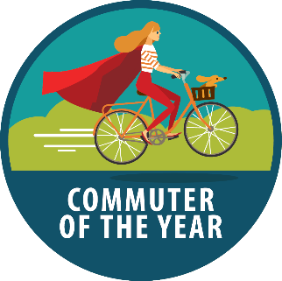

Download the App: By now, you have all discovered how easy it is to log trips. But did you know that it gets even easier?! Don’t believe me? – download the free “Commute Tracker” app and see for yourself. The app will track you as you travel between your home address and your workplace so that when you arrive, all you need to do is confirm your mode and the rest of the work is done for you. Your trips will automatically be logged to your account.
See how the competition is shaping up on the Challenge Leaderboards!

Small Employers Leaderboard
Medium Employers Leaderboard
Large Employers Leaderboard
Macro Employers Leaderboard

Signed, XXXXXX
Your Commuter Challenge Captain

Send out date: Wednesday, September 23rd

Team Workplace Name,

Guys. Real talk. Our opportunities to win the commuter challenge are dwindling! This Saturday is the LAST day of the challenge so make sure you try a sustainable mode and log your trip as soon as possible! The official last day to log a trip is Wednesday September 30th.

Do you have any fun commute stories from the past week and a half? If so, you should share them! (Perhaps start by sharing one of your own stories).

And I know we are all certified experts at logging trips by now, but have you discovered the nifty “Favorite Trip” feature? It allows you to save your frequently traveled routes so that you don’t have to re-enter mileage or the start and end destinations when using the trip planning tool. Here’s a short video on how to save a Favorite Trip.
Also, as our wise culture has taught us, doing something awesome in your life doesn’t actually count unless you take a photo of yourself doing the awesome thing, post the photo on social media and get an acceptable number of likes. Which means it’s time to step up Team WORKPLACE’S social media game! Tag @missoulainmotion or use #missoulainmotion to be in the running for Best Social Media Presence and Best Team Photo!
Keep up the good work!

Signed, XXXXXX
Your Commuter Challenge Captain

Send out date: Friday, September 25th

TGIF! TODAY/tomorrow (depending on whether your week ends) is the last day!

Many of you are dreaming of your free ice cream for achieving the 10-Day Medalist status this year - congratulations!

Remember, ALL sustainable commutes must be logged at waytogo.missoulainmotion.com by Wednesday, September 30th at 5pm. But, you should go ahead and do it now!
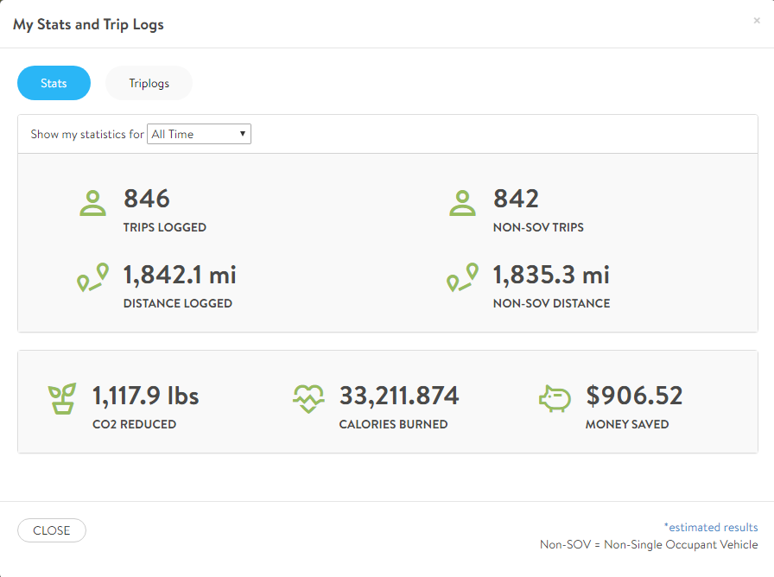
Now that the challenge is wrapping up, you can calculate the amount of CO2 your sustainable trips diverted as well as the cash-money you saved! To find these stats, simply login at waytogo.missoulainmotion.com and open your “Dashboard”. From there you can scroll down to see your stats on the right hand side. Select the “All my stats” to see a full list of your impact.

And did you know the prizes and rewards don’t stop now? You can earn a monthly reward EVERY month via Way to Go! Missoula! Each month, Missoula In Motion partners with a local business to offer sustainable commuters an awesome reward- just for biking, walking, busing, or telecommuting! Did you see the awesome prizes for September?? Be sure to claim yours now! Learn how to claim and see what’s coming up for October here.
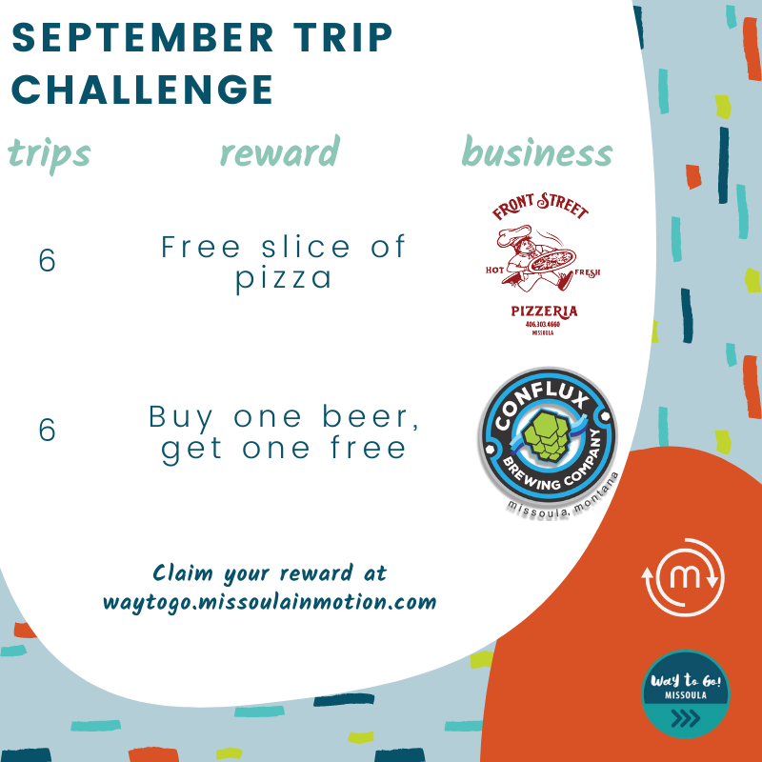

Thanks to everyone for your efforts these past two weeks! I'll keep you posted on our participation total!

Signed, XXXXXX
Your Commuter Challenge Captain

