Intro Email for First Time Challenge Participants:
The email below is a template you can use to invite first-time participants to participate in the Commuter Challenge. Feel free to write your own or edit the template below to fit your specific workplace. Please note the red bolds and edit as appropriate.

Helpful Hint: You will need to copy and paste the Shareable Join URL that is unique to your Workplace Network. This allows participants to automatically join your team when they register for Way to Go. *Refer to screenshots on following page*. To access the URL: log in to your Way to Go! Missoula account and select your Workplace from the “Manage” tab. From there, select the “Edit” sub-tab.

SEPTEMBER 19 – OCTOBER 2
Sign up. Commute Sustainably. Log trips. Earn Rewards.

Did you know that transportation is the number one contributor to greenhouse gas emissions in the Missoula Valley? At ‘Workplace Name’, we’re challenging ourselves to be a part of the solution by exploring other ways of commuting during Missoula In Motion’s Commuter Challenge this Fall!

HEAD TO HEAD COMPETITION
We’ll duke it out against workplaces of a similar size to see who can make the most sustainable commutes to work between September 19 and October 2, 2021. Discover all of our transportation options, create new healthy habits, win cool prizes every day!

ITS SUPER EASY
All we have to do is log our trips on Way to Go! Missoula. If we are the ONLY team in our size category to have everyone log at least ONE sustainable commute between September 19th and October 2nd, then we WIN!!!

FALL FOR A COOL COMMUTE
Summer’s a great time to commute more sustainably, but this year the challenge is to see if we can keep it up through the Fall. Whether it's walking, biking, taking the bus, carpooling, vanpooling, or even (yes!) teleworking – let’s encourage each other to give it a try and see if you Fall for a Cool Commute! Even if it’s just one time- just one trip! That’s all it takes! We can do it!

Sign up for the Challenge as a member of Team Workplace Name here: (insert Shareable Join URL)

Now you can start logging sustainable commutes and tracking your impact! Watch this How-to-video to see how easy it is to log trips with Way to Go! Missoula.
Navigating to your Workplace Network:
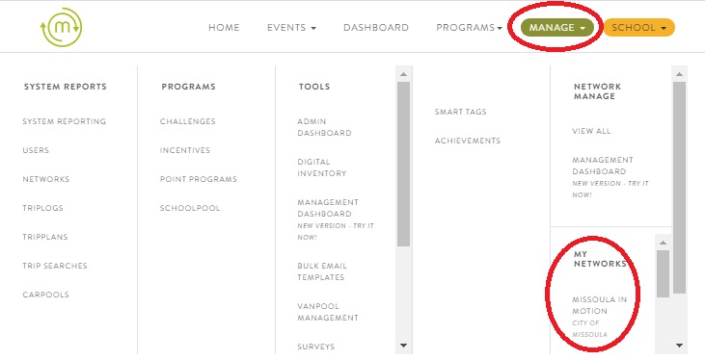

Finding your Shareable Join URL:
