Commuter Challenge Email Templates Week 2 (May 8th - 14th)
Missoula In Motion has prepared some sample email messages that might be useful to you as you spread the word about the Commuter Challenge in your workplace. Feel free to and/or edit the materials to suit your purposes, style, weather etc. (please note the red bolds and edit as appropriate):

Send out date: Monday, May 9th
Hi everyone!

Happy week 2 of the Commuter Challenge! Have you logged your sustainable trip yet? Logging your telework, bus, bike, carpool, or walk trip on Way to Go! Missoula brings our team one step closer to victory AND enters you into a daily raffle for a $50 gift cards!
Week 2 Raffle Schedule
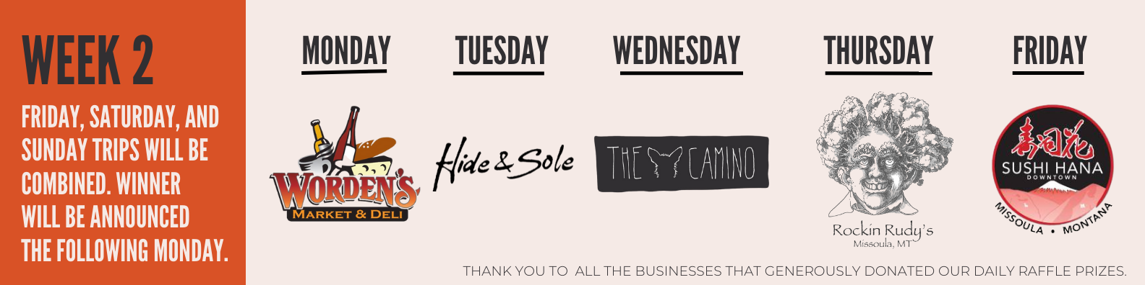
Top Tips:
Juggling the morning school/childcare drop off and a sustainable commute? Here’s an idea – drive your kids to school/daycare, then park your car there and hop on a bike or bus for the final leg of your trip to the office. Use the school’s address as destination #1 when logging your trip.

Do you live outside of the bus’s service area? Consider parking your car by a bus stop that’s on your way into town and ride the bus the rest of the way. Here are the Mountain Line Bus Map & Schedule and U-Dash bus map & schedule. Refer to the Way to Go Trip Planner for Park & Ride locations. Look for an address nearby the bus stop to log your trip from.

Have you tried the Commute Tracker App? By now, we’ve all discovered how easy it is to log trips. But did you know that it gets even easier?! Don’t believe me? – download the free “Commute Tracker” app and see for yourself. The app will track you as you travel between your home address and your workplace so that when you arrive, all you need to do is confirm your mode and the rest of the work is done for you. Your trips will automatically be logged to your account.

See how the competition is shaping up on the Challenge Leaderboards!

Micro Category Leaderboard
Small Category Leaderboard
Medium Category Leaderboard
Large Category Leaderboard
Macro Category Leaderboard

Signed, XXXXXX
Your Commuter Challenge Captain

Send out date: Wednesday, May 11th

Team Workplace Name,

We. Can. Still. Win! This Saturday is the LAST day of the challenge so make sure you try a sustainable mode and log your trip as soon as possible! The official last day to log a trip for the Challenge is Wednesday May 18th.

Do you have any fun commute stories from the past week and a half? If so, I’d love to share them with MIM. (Perhaps start by sharing one of your own stories).

Top tips:
Have you tried the Favorite Trip feature? I know we’re all certified experts at logging trips by now, but have you discovered the nifty “Favorite Trip” feature? It allows you to save your frequently traveled routes so that you don’t have to re-enter mileage or the start and end destinations when using the trip planning tool. Here’s a short video on how to save a Favorite Trip.
Here’s another way we can win: stepping up Team WORKPLACE’S social media game! Tag @missoulainmotion or use #missoulainmotion to get us in the running for Best Social Media Presence and Best Team Photo!
Keep up the good work!

Signed, XXXXXX
Your Commuter Challenge Captain
Send out date: Friday, May 13th

TGIF! Tomorrow is the last day of the Commuter Challenge!

Many of you are dreaming of your free ice cream for achieving the 10-Day Medalist status this year - congratulations!

Remember, ALL sustainable commutes must be logged at waytogo.missoulainmotion.com by Wednesday, May 18th at 5pm. But, you should go ahead and do it now!

Now that the challenge is wrapping up, you can calculate the amount of CO2 your sustainable trips diverted as well as the cash-money you saved! To find these stats, simply login here and click on ‘mine’ under STATS.

And did you know the prizes and rewards don’t stop now that the Challenge is ending? You can earn a monthly reward EVERY month via Way to Go! Missoula! Each month, Missoula In Motion partners with a local business to offer sustainable commuters an awesome reward- just for biking, walking, busing, or telecommuting! Did you redeem your reward for May yet? Learn how to claim and see what’s coming up for June at the bottom of your Dashboard here.

Thanks to everyone for your efforts these past two weeks! I'll keep you posted on our participation total!

Signed, XXXXXX
Your Commuter Challenge Captain

